Youth Leadership Conference (YLC)
San Diego – 2014
This year’s YLC was held for the second time at San Diego State University, June 22 - 26. Thirty six students attended, with the majority of them coming from JROTC Units from the Navy, Army, Marine Corp and Air Force. As many as 12 students come from charter schools and public schools without JROTC Units.
A visit was made on the first day of the Program by Past Vice-Commander Tom Morgan, YLC/JROTC Coordinator Nick Herbka and Chapter Guest Dr. Jim Oster. The first guest speakers from the Marine Corps gave an impressive class on the Fundamentals of Leadership. They gave the students much to think about, in their roles, as leaders in high school and JROTC Units.
The Top student of this year’s YLC was C/CDR John Pilapil from Westview HS NJROTC Unit. He will represent the San Diego YLC in the National MOWW competition for the Phoenix Award. Last year’s Phoenix Award winner was a student from the YLC conducted in San Diego.
Our Chapter Supported 5 students this year from Orange Glen HS NJROTC (2), Ramona HS NJROTC (2) Westview HS NJROTC (1). The cost of supporting a student for YLC went from $150 in 2013 to $400 in 2014. We gave $250 per student to attend this year’s conference. Thanks to our Chapter Companions and Guests, over $1500 was donated this year. Next year we hope to expand the number of students we support for this YLC, which is filled with patriotism, leadership, teamwork and a sincere appreciation for the capitalistic economic system with has made America the Greatest Nation in the World.
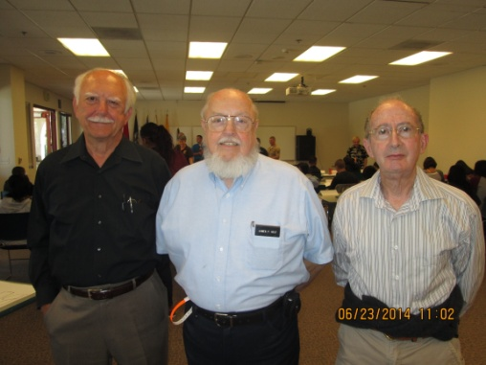 Tom Morgan, Jim Helper, Dr. Jim Oster
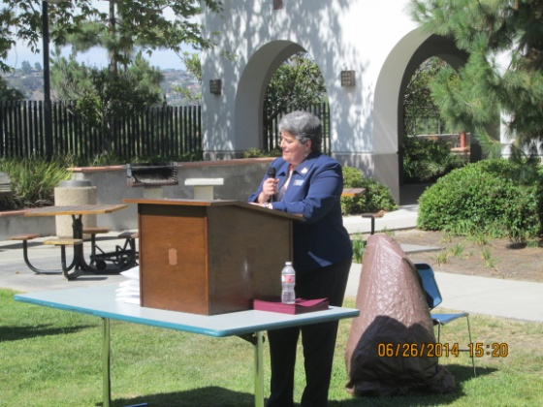 MOWW CINC Debbie Cash presents Student Awards. CINC Cash administered and instructed in the San Diego YLC. Her husband is the new Commander of the Pendleton Chapter.

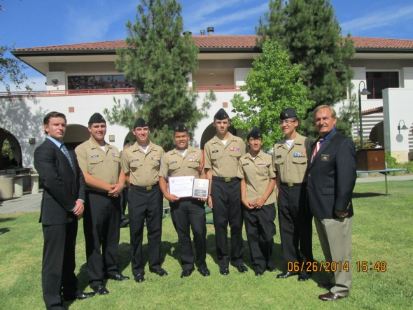 Chapter Commander Nick Herbka poses with students, supported by Gen. JP Holland Chapter for the 2014 San Diego YLC.

